Planning application 22/02935/FUL
Comments submitted by Tysoe Parish Council regarding letter from SLR to Planning Officer, dated 13th October, 2023
The following comments are submitted by Tysoe Parish Council (TPC) and relate specifically to the amendments advised to the Planning Officer in the above letter. Our comments are presented in the same order as SLR’s document.
- Agricultural Land Quality Report – TPC has already expressed the view that to take any land out of food production to provide feedstock for a digester in the way envisaged by the applicant would be folly. We do not make any additional comment here.
- Air Quality Assessment – in our objection, submitted on 9th December, 2022, we expressed significant concern regarding the traffic that the proposed digester would generate. We expressed the view that the applicant had significantly underestimated the traffic volume and therefore the pollution that would be generated. We believe that still to be the case notwithstanding any amendments now submitted by the applicant. The site is in an SSSI risk zone. Natural England have been consulted but have not responded in terms of the SSSI risk zone, even though at 12,437m² the digestate lagoons have a surface area well over the 750m² threshold.
- Arboricultural Feasibility Report – no comment by TPC.
- Arboricultural Implications Assessment – no comment by TPC.
- Biodiversity Net Gain Report - Whilst the proposed BNG actions increase opportunities for some forms of biodiversity they do not compensate for the impact on the less common species in the locality. They do not, for example, compensate for disturbance to curlews or to bats. The main change in land use is the loss of 5.42 ha of land to sealed surface which reduces the habitat for species that use farmed land. In the case of the brown hare in particular, the loss of 7.25 ha cropland may constitute a significant loss of habitat and the Biodiversity Net Gain actions will not compensate for that loss. In addition, the BNG Assessment is partly based on the creation of narrow, linear grassland features which will be subject to a high level of edge effect and spray from vehicle movements, and it is hard to imagine these will ever achieve more than a very moderate improvement.
- Flood Risk Assessment – TPC remain of the opinion that there is a high risk of leakage of contaminated digestate from the site and, with such a very large area of paved or hard-surface, the risk of flood run-off remains very significant. This is especially concerning, as the site drains into the adjacent watercourse which is within the SSSI risk zone, a tributary of the river Dene which flows onto Lobbington Hall SSSI. The flood risk matter is very well covered in the letter (8th November, 2023) from WCC’s Flood Risk Management Officer in which she highlights the lack of clear information and data.
- Heritage and Archaeological Desk Based assessment - The applicant has only paid regard to the impact that the proposed industrial plant would have on immediate statutory designations. It continues to ignore the imposition of the facility on the wider area of historic buildings, Conservation Areas and the rich unspoilt historic landscape to which it is focal. No attempt has been made by the applicant to address these concerns.
- Landscape and Visual Assessment – In our original objection, submitted in December 2022, we highlighted one of our main objections as being the impact on the landscape, in particular the impact on views from the adjacent Cotswold AONB. The applicant has struggled to demonstrate any mitigation of this major flaw in their application. We don’t believe that any of the amendments change the fact that the application contravenes the following SDC Planning Policies and National Planning guidelines: CS.1; CS.5; CS.9 CS.12; CS.22; AS.5; AS.10; NPPF 174, 175 and 176. The applicant continues to take a highly theoretical approach to demonstrate that there will be minimal impact on the landscape. However, it is obvious to any observer that the erection of a large, industrial gas plant, with its associated paraphernalia, in full sight of the adjacent AONB and on virgin green space will create irreversible damage and blight that currently unspoilt landscape. The planning policies referred to above, which the application breaches, were designed largely to protect exactly the kind of landscape that this development would ruin. We continue to stand by that view notwithstanding any of the amendments the applicant has submitted. Indeed, their own updated LVA appears to support our view. Any installation of lightning protection masts would also add to the visual intrusion as would probably need to be taller than the domes.
- Lighting Assessment and Strategy – currently there is very little light pollution in the area of the proposed gas plant. Tysoe has adopted a “Dark Skies” policy in its Neighbourhood Development Plan and the Cotswold AONB has a similar policy. In our original objection to the application, we pointed out the very real issue of light pollution emanating from the proposed plant as did Cotswold AONB in their objection. Whilst the applicant may have attempted to mitigate such pollution in their May 2023 lighting strategy, we don’t believe that this is sufficient. The view from the AONB, almost 300ft above the level of the proposed plant, would still be marred by the lighting of the plant. We cannot see any way in which this light pollution can be fully mitigated or avoided. As the updated LVA concedes, even with the new lighting strategy ‘ that the proposed development would have some impact on Dark Night Skies’.
- Noise Assessment – here again, as with air pollution (see comments at 2 above), we pointed out in our original objection that the applicant had significantly underestimated the volume of heavy commercial traffic required to deliver feedstock and export digestate and bio-gas. We believe that still to be the case as the applicant has not made any re-assessment of crop yields and transport routes – main drivers of the transport logistics. Transport, we believe, will be the main driver of noise pollution generated by the application and that has not been fully addressed by the applicant. Given the size of the proposed gas-plant and its feedstock requirements we cannot see how the applicant can undertake not to cause significant noise pollution. The issue of machinery noise and its impact on local residents living within 300m of the proposed plant has still not been addressed. Given that much of the machinery used is stated to be far quieter than identical machinery in the applicant’s many other developments, we question the accuracy of the data on which the noise assessment is based.
- Preliminary Ecological Appraisal – The PEA was based on there being no waterbodies on the site. Now that the adjacent watercourse is included in the drainage strategy of the development, as it is on land ‘within the landholder’s control’, should it not also be included in the PEA? Also, the pond just beyond the northern tip of the site was excluded from the PEA, although on the new land ownership documents this pond is now within the red site boundary. The great crested newt (GCN) scoping survey is unclear about whether there are 2 or 4 ponds within 250m of the site and there are no details of when it was carried out, so we question its reliability. As AD plants cannot be built within 250m of the presence of GCN, where it is linked to the breeding ponds of the newts by good habitat (SR2021 No 7), and given the number of recorded sightings of GCN within 2km of the site, evidence of their presence or non-presence must be reliably obtained. The possible adverse effects on Curlews are still not addressed. Although the lighting has been designed to be ‘bat sensitive’, as the updated LVA concedes, even with the new lighting strategy ‘ the proposed development would have some impact on Dark Night Skies’ so would still have the potential to harm bats, given the scale. One new piece of information with regard to bats – they were monitored by the Warwickshire Bat Group just outside the circle in Drawing 3 in the ecology document and the monitor recorded at least 10 of the 14 species ever found in Warwickshire, indicating that this is an important locality for these species! The revised documentation does not take into account the Banbury Ornithological Society submission on curlews, which use land within the area enclosed with a dashed line in Drawing 3. The applicants have not contacted Banbury Ornithological Society to discuss the concerns raised. This is the most important remaining curlew stronghold in Warwickshire and their conservation is a very high priority.
- Preliminary Land Quality Risk Assessment – Although not a substantial change from the previous PLQRA, the site is within an SSSI risk zone. Natural England have been consulted but do not seem to have responded in terms of risk to the SSSI. Does this need to be addressed? (NE should be consulted in this area for slurry lagoons & digestate stores > 750m², manure stores > 3500t. and for any discharge of water or liquid waste of more than 20m³/day to ground (i.e. to seep away) or to surface water, such as a beck or stream – which this might?)
- Statement of Community Involvement – our comments in our original objection still stand. The applicant has made very little effort to engage with the local community and when they did, they were evasive, contradictory and generally unhelpful. Nothing has changed.
- Transport Statement – we pointed out, in our original objection, that the applicant had significantly underestimated the volume of traffic that the proposed plant would generate. Although they have substantially uplifted the vehicle movement numbers, we believe these are still significantly underestimated. This, together with the impact on the landscape, represents the most egregious breach of the duty of care that the applicant owes to the local community. Nothing in these amendments changes the fact that the applicant is still significantly underestimating the impact that heavy commercial traffic will have on the network of narrow lanes surrounding the proposed site. We are still firmly of the belief that the air and noise pollution and the congestion, damage and disruption caused by the huge volume of incremental traffic caused by this proposed plant, within the parish and the surrounding area as far as Banbury, will be significant and very damaging. The applicants traffic calculations still under-estimate the volumes that will be generated. Their assertion that most of the traffic is already on the surrounding roads is completely false. There is no evidence that this is the case, and the assertion is entirely illogical. The applicant’s unwillingness to divulge where the feedstock for the digester will be sourced is a continuing concern. Without this information they cannot have made any accurate assessment of transport impacts.
- Planning and Design and Access Statement – no further comments by TPC.
- Drawings – to the extent that the changes to the drawings and images represent the changes discussed above, TPC has no comment to make.
In reference to the updates to the photomontages in the LVA report, the methodology used has resulted in misleading images that make the buildings appear much further away than they actually are. Acorn have used ‘panoramic’ imagery incorporating 4 photographs shot in portrait format, on a 50mm lens, and stitched together to form one very wide image.
As a result, these images are designed to be viewed printed on A1 size paper (594mm x 841mm) and viewed at arm’s length to replicate what we see with the naked eye. We would argue that not many people have viewed these at A1 size (if any), therefore these panoramas are too small to provide a true representation of the proposed development.

Based on best practice from the ‘Landscape Institute’s Technical Guidance Note, 3.7.3 Visualisation Type Methodology’ “…image enlargement, to illustrate perceived scale, would be appropriate”, we would also question the appropriate use of the panorama imagery in this instance. Panoramas are more suited to sites that cover a far larger footprint in the landscape, such as windfarms. The standard 50mm lens photo printed at A3 size is much more appropriate and will provide a true representation of the proposed development.
We also still maintain that the ‘Viewpoint 3’ is still inaccurate. The tree line adjacent to the digesters is 16m tall yet appears much taller than the digesters which are 16.5m tall. The latest ‘winter’ photomontage from Acorn also appears to have reduced the height of the digesters quite dramatically, see imagery comparison below.
By this “sleight of hand” Acorn demonstrate their contempt for the many people who would be affected by this unwanted development.
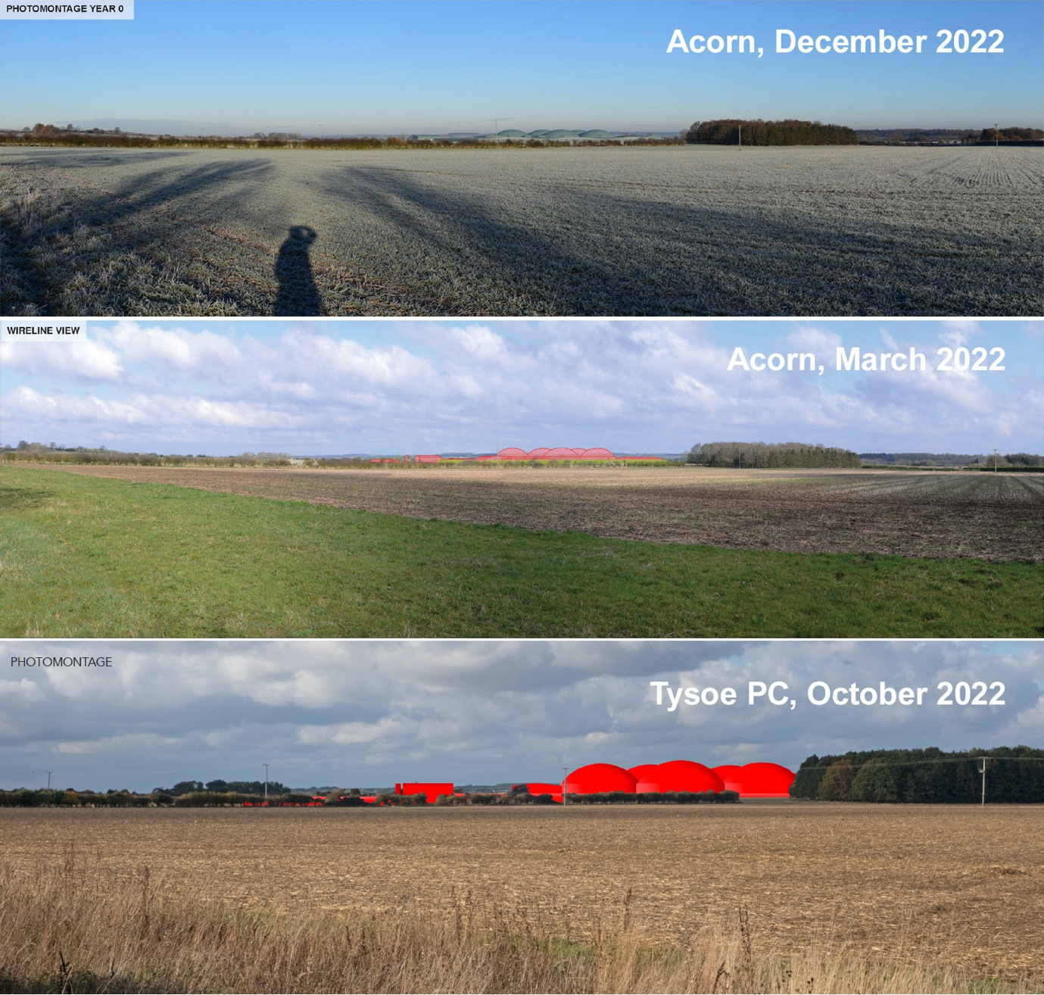

Further comments:
Arup Gap Analysis Response:
LNG/LPG (both are mentioned) delivered by ‘no more than one tanker per day’ will be used to fuel the plant itself. The carbon methodology uses figures for natural gas from the grid, but a grid connection is not possible here. This will affect the carbon calculations.
If propanation is now not required at the site or the hub, why is a propane tank include in this site plan and the injection hub site plan?
With HSC not yet confirmed at Banbury Hub and likely to take 12 months to be decided and the Newton Longville Hub application being recently withdrawn, it is not yet clear where the gas will eventually be injected and so carbon calculations will not be accurate.
Neither the Arup Report or Acorn’s Carbon Calculations include the enormous carbon costs of building and decommissioning the site. For how many years will the site need to be operational before it has offset these carbon costs? Recent applications, determined by SDC, have permitted the erection of solar farms on open green land on the basis that such installations could be relatively easily reversed at end of life. This does not apply to this large-scale industrial gas plant, together with its infrastructure, proposed by the applicant. This would be extremely difficult and expensive to demolish if it were to become non-viable in future. Also, the land taken out of food production in order to provide feedstock for the digester, needs to be taken into consideration. Our understanding is that this is against current SDC policy. We vigorously re-state our assertion that this proposal is absolutely not “green” in any sense of that description and the harm it will do to the local community and environment far outweighs the vanishingly tiny benefit that will accrue to local residents. Even if considering the benefit at a national level, it is difficult to conclude that the miniscule (in national terms) volume of gas made available to a market in which gas-fired boilers are soon to be banned, compensates for the irreversible and vast damage that this ill-conceived plant will do to the natural environment and the community surrounding the proposed site.
In addition to the specific changes discussed above, the applicant discusses the issue of lightning strike in their covering letter. This has clearly been prompted by the recent catastrophic lightning strike on a similar gas-plant in Oxfordshire. We take scant comfort from their assurances as it is very likely that the operators of the plant in Oxfordshire had installed what they believed to be adequate safeguards and operating standards, as Acorn is proposing. It is difficult to get beyond the fact that the plant, by its very nature, will comprise several tanks full of highly explosive gases. If lightning were to strike, it is highly likely that the result would be catastrophic. The applicant has, again, ignored the impact that such a catastrophe would have on the houses that are less than 300m from the site. The proximity to a very large MOD munitions storage facility makes the issue of catastrophic explosion far more of a concern than may otherwise be the case.
Summary
The key arguments in our original objection were:
- That it was virtually impossible to disguise a very large industrial gas generating plant built in open, green countryside in full view of the Cotswold AONB.
- That the traffic generated by the plant (underestimated by the applicant) would do enormous damage to the local community.
- That air, noise, and light pollution, in an area where virtually none exists today, would be significant and harmful.
- That the harm done to the local community would vastly outweigh the negligible (zero?) benefits.
- That the proposal contravened numerous local and national planning policies and guidelines.
We cannot see anything in the latest amendments that would reduce or dilute those arguments.
In their application Acorn has not respected the wider aspects of human geography. In fact, they have consistently ignored the 6 dwellings that lie less than 300m from the proposed site. They have ignored these in their discussion of noise and air pollution and ignore them in their discussion regarding lightning strike. This is a symptom of their failure to address the wider environmental impact on people’s lives. The applicant picks out the parts of the NPPF that it can answer most easily to its own satisfaction. It clings to the NPPF’s statement that ‘ at the heart of the framework is a presumption in favour of sustainable development’, i.e. that the elements of harm have to be overwhelming. Every single point Acorn makes is predicated in that direction. The adverse effects on people using footpaths, cycling, riding horses or using local roads are mitigated by limp arguments. Acorn paints a narrow picture of impact whereas the impact is much broader and varied than the straitjacket of tick-box planning allows.
We cannot see that Acorn has improved its argument other than by loading in even more data to obfuscate the issues. The main objections (visibility, transport, wider impact on people’s lives etc, landscape intrusion etc.) have not been mitigated to any great degree and still hold good. They are the main- stays of our objection.
We believe that the applicant has now been given more than enough time to respond to the overwhelming number of objections raised by statutory consultees and individuals. It is very difficult to see how the application can be further amended to render it acceptable in any way.
Tysoe Parish Council maintain its very strong objection to this application, and we implore the Planning Authority to issue a determination of the application as soon as possible.

