Planning Committee Report – October 2023

Current Consultations

Application Number | Address | Details | Consultation expiry
23/01946/FUL | Winchcombe Farm Shenington Road Upper Tysoe Warwickshire  CV35 0TH | Change of use of two buildings from residential Holiday Let usage to residential usage ancillary to the main building. No changes to internal or external layout or appearance | 04/09/2023
Recommendation – Object for the following planning reasons
- Contravention of the Original Planning Permission Conditions.
When the holiday lets concerned were originally granted planning permission, it was on condition that they would not be used for permanent residential occupation as this 'would represent an unsustainable form of development in accordance with Policies CS.1, CS.5, CS.9 and CS.10 of the adopted Stratford-on-Avon Core Strategy (2011-2031)' given the open countryside location. We believe this still holds true only a few years later and granting such change of use so soon could set an unsustainable precedent.
- More Evidence for the Business Case Required.
Whilst sympathetic to the applicant’s financial situation we do not believe enough evidence (such as a business plan to demonstrate the essential need for persons to be always present on the site for the efficient and secure operation of the business, sufficient to justify the provision of residential accommodation) has yet been submitted. Nor has it yet been shown that these letting sites have no reasonable prospect of being viable. We would expect such evidence for any change of use under Tysoe NDP Employment Policy 1. If the future sustainability of the enterprise is in doubt, then provision of permanent housing for staff must, surely, also be in doubt.
- Unsustainable Location, Inconsistent with CS.20 and AS.10
CS.20 states the conversion of existing buildings into dwellings will be supported ‘where the residential use is acceptable in principle’, which is not the case here. AS.10 states all proposals will be thoroughly assessed against the principles of sustainable development, and this proposal is not in a sustainable location for residential dwellings.
Make no representation. |  | Object |  | Date Decision made
Support the application. |  | No Objection |  | Who will represent the PC at committee?

Application Number | Address |  |  |  |  | Details |  | Consultation expiry
23/02333/FUL | 5 Church Farm Court Tysoe Warwickshire CV35 0TE |  |  |  |  | New windows, cladding to the outside of the house and convert half the garage to give a bigger kitchen and utility |  | 10/10/2023
Recommendation – No Objection.
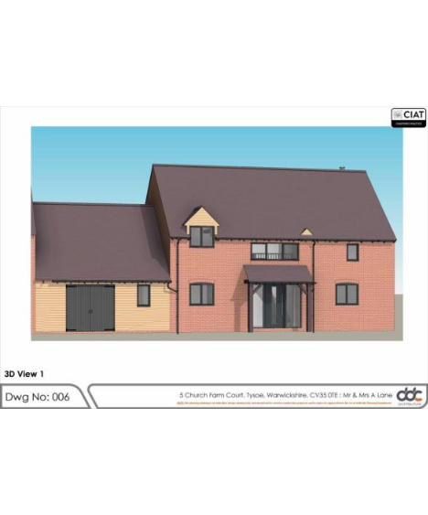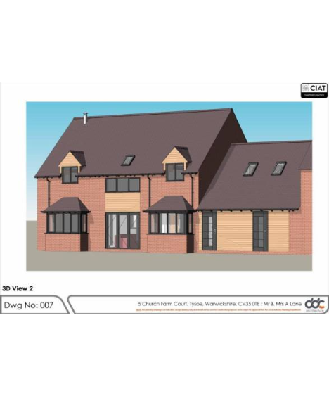

Make no representation. |  |  | Object |  | Date Decision made
Support the application. |  |  | No Objection |  | Who will represent the PC at committee?

Current Tree Consultations

Application Number | Address |  |  |  |  | Details |  | Consultation expiry
23/02341/TREE | Yew Tree Cottage Main Street Middle Tysoe Tysoe Warwickshire CV35 0SF |  |  |  |  | T1 and T2 - yew trees reduced in height by 1 metre this is about 1/5 of its height and then around 1/2 metre overall pruning as they are large and too big for a small front garden |  | 16/10/2023
Recommendation – No Objection
Make no representation. |  |  | Object |  | Date Decision made
Support the application. |  |  | No Objection |  | Who will represent the PC at committee?

Decisions Issued Since Last Tysoe Parish Council Meeting

Application Number | Address | Details | Tysoe Parish Council Comments | Target date for Decision | Decision Date | Decision
23/02233/TREE | Byeways Main Street Middle Tysoe Tysoe Warwickshire CV35 0SW | -T1 Cotoneaster - Removal. -T2 rowan - Removal | No objection | 02/10/2023 | 02/10/2023 | No objection

Previous Consultations, still Pending Consideration

Application Number | Address | Details | Target date for decision
23/02281/FUL | 1 Templar Close, Lower Tysoe, Warwick, CV35 0GT | Retrospective planning permission to regularise the removal of part hedging along the Southern boundary and erection of decking and fencing | 19/10/2023
23/02177/COUNTY/  SDC/23CM011 | Sewage Works, Back Lane, Tysoe | Installation of one kiosk (motor control centre) at Sewage Treatment Works, West of Lower Tysoe, Warwickshire
23/01836/FUL | 2 Peacock Lane Tysoe Warwickshire CV35 0SG | Construction of link detached garage and carport | 21/09/2023
23/01737/FUL | Westcote Stud Ltd Tysoe Road Radway Warwickshire CV35 0BS | Change of use to a mixed use for a secure dog walking and equestrian land together with the addition of a field shelter and re-location of a field shelter | 20/09/2023
23/01010/FUL | Land North Of Somerton House Lower Tysoe Warwick CV35 0BZ | Construction of single, detached, self-build dwelling | 04/08/2023
22/02935/FUL | Land Adjacent To Hardwick Gorse Tysoe Road Kineton Warwick | Construction of anaerobic digestion facility, comprising silage clamps, digestor tanks, lagoons, administrative buildings, landscaping and access. | 03/01/2023
22/01806/FUL  22/01807/LBC | Home Farm Lower Tysoe Warwick CV35 0BZ | Residential development of redundant farm buildings, including listed stable, to 3 residential dwellings | 11/08/2022
20/03658/FUL | Land Off Sandpits Road Tysoe | Full Planning application for proposed removal of existing building and proposed development of 31 new residential dwellings, new vehicular and pedestrian access, public open space, landscaping and other associated works. | 03/03/2022  Revised Target Date for Determination 03/03/2022

