Planning Committee Report – November 2023

Current Consultations

Application Number | Address | Details | Consultation Expiry
23/02679/FUL | Dinsdale Cottage Baldwins Lane Upper Tysoe Warwick CV35 0TX | Construction of a new vehicular entrance to dwelling house | 08/11/2023
This proposal entails the creation of a vehicular of access through an existing stone boundary wall.

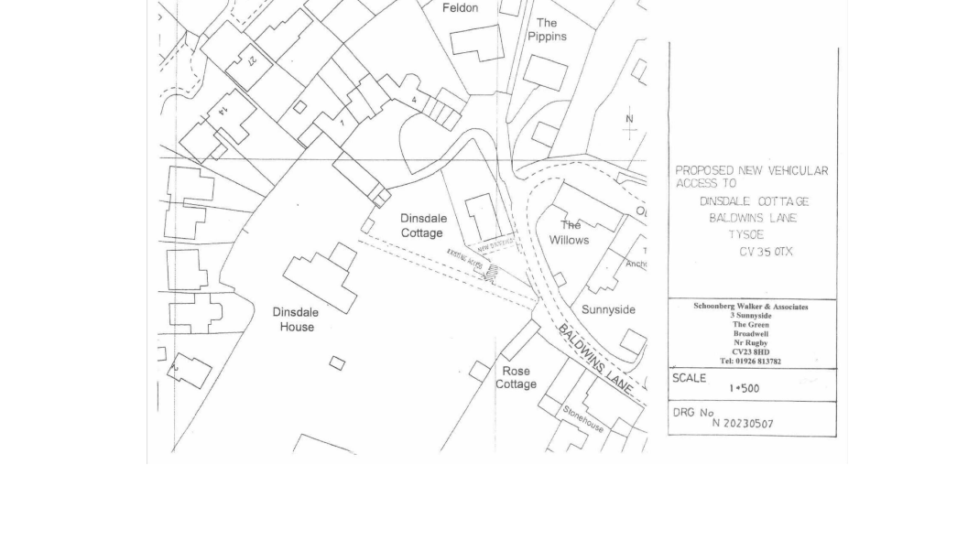

Recommendation – No objection, subject to the following conditions
i) Any highway conditions as proposed by WCC Highways Department
ii) A turning area be created within the site to enable vehicles to enter and leave the site in a forward direction.
iii) The two sides of the opening to be created through the existing stone wall shall be constructed in matching stonework.

Make no representation. |  | Object |  | Date Decision made
Support the application. |  | No Objection |  | Who will represent the PC at committee?
Application Number | Address |  |  |  |  | Details |  | Consultation Expiry
23/02010/FUL | Tysoe Vale Farm, Bungalow At Tysoe Road Lower Tysoe Warwickshire CV35 0DY |  |  |  |  | Proposed demolition of stable block and erection of replacement building containing three garages and stores for domestic use in association with 3 existing dwellings Tysoe Vale Farmhouse, Barn, and Bungalow at Tysoe Vale Farm |  | 08/11/2023
The application proposes the replacement of an existing single storey stable block, approximately 4m wide by 20m long (formerly a poultry shed), constructed of timber-clad blockwork with an asbestos sheet roof. The new building will create space for three cars with additional covered area (all within the existing footprint), being constructed in materials to match existing adjoining buildings ie walls in brickwork, with green sheet steel rear wall to match materials in the newly built agricultural building in the adjoining field, the roof being tile in interlocking ‘plain tile’, again, to match adjoining buildings.
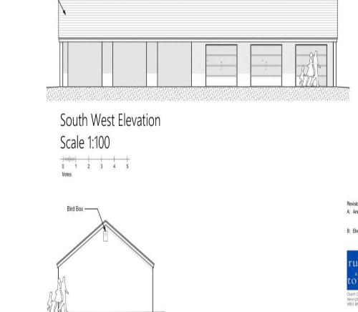

Recommendation - No objection subject to the following conditions
i) Samples of materials being submitted for approval of the LPA
ii) A landscaping/tree planting scheme.
Make no representation. |  |  | Object |  | Date Decision made
Support the application. |  |  | No Objection |  | Who will represent the PC at committee?
Application Number | Address |  |  |  |  | Details |  | Consultation Expiry
23/02823/FUL | 13 Poolgate Upper Tysoe Tysoe Warwickshire CV35 0TS |  |  |  |  | Erection of single storey side extension following demolition of garage. |  | 13/11/2023
The proposal entails extending an existing side extension and replacement of an existing carport - to the front to rearrange the entrance and existing kitchen and to the rear for an additional bedrooom. The extension will be built in brick with a tiled roof.
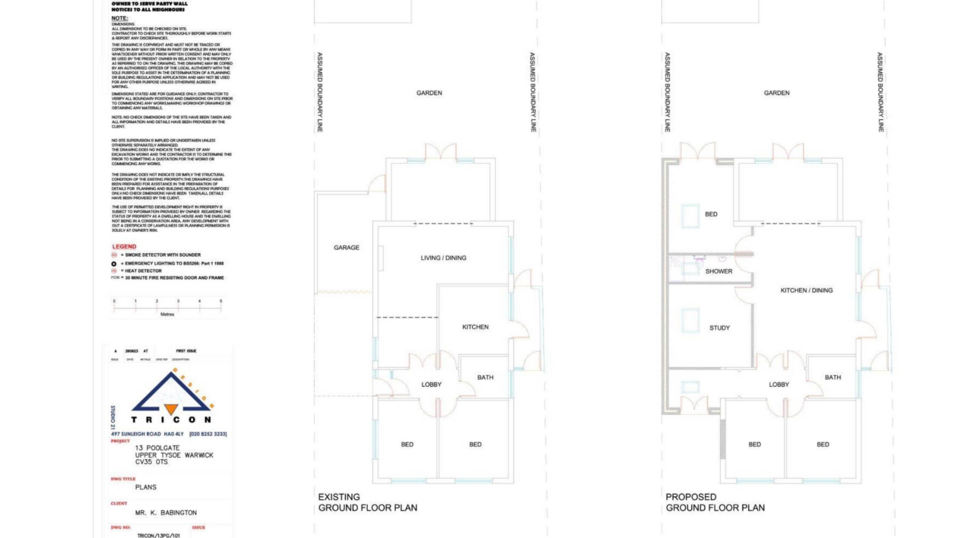

Recommendation – No Objection subject to materials matching existing

Make no representation. |  |  | Object |  | Date Decision made
Support the application. |  |  | No Objection |  | Who will represent the PC at committee?
Application Number | Address |  |  |  |  | Details |  | Consultation Expiry
23/02934/FUL | Byeways Main Street Middle Tysoe Tysoe Warwickshire CV35 0SW |  |  |  |  | Erection of summer house |  | 29/11/2023
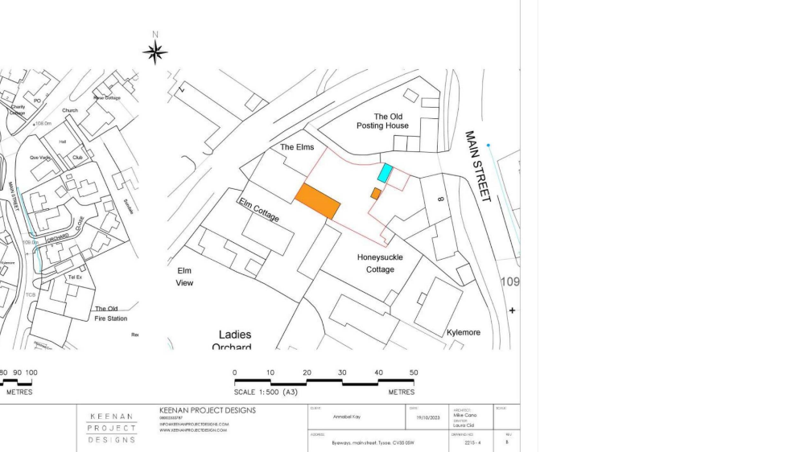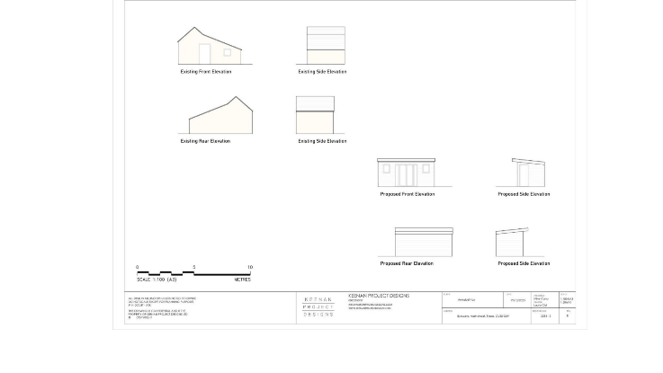

Recommendation – This application has only very recently been received. Following an initial site visit, we request further time to consider this proposal as there are a few points needing further clarification.

Make no representation. |  |  | Object |  | Date Decision made
Support the application. |  |  | No Objection |  | Who will represent the PC at committee?

Current Tree Consultations

Application Number | Address | Details | Consultation Expiry | Planning Committee Recommendation
23/02800/TREE | The Cottage Peacock Lane Tysoe Warwickshire CV35 0SG | -T1 yew - Crown lift up to 3.5metres removing lower epicormic growth. -T2 apple - Crown reduction by 3metres to bring it back to it's previous size and in scale. -T3 and T4 apple - Crown reduction by 2metres to bring scale back to previous size. -T5 and T6 pear - Reduction in height by 4metres, scale to be re-aligned with the rest of the garden. -T7 alder - Fell. -T8 hazel - Coppice to manage re-growth and keep away from highway. -T9 plum - 2metres off the top, in line with the rest of the orchard. | 09/11/2023 | No Objection
23/02968/TREE | Holly House 11 Smarts Lane Upper Tysoe Warwick CV35 0TT | T1, T2 and T3 - hornbeam - Crown reduce to similar size and shape to approx 1.2metres to a conical form | 28/11/2023 | No Objection

Decisions Issued Since Last Tysoe Parish Council Meeting

Application Number | Address | Details | Tysoe Parish Council Comments | Target date for Decision | Decision Date | Decision
23/01836/FUL | 2 Peacock Lane Tysoe Warwickshire  CV35 0SG | Construction of link detached garage and carport | Support | 21/09/2023 | 6/10/2023 | Permission with Conditions
23/02281/FUL | 1 Templar Close, Lower Tysoe, Warwick,  CV35 0GT | Retrospective planning permission to regularise the removal of part hedging along the Southern boundary and erection of decking and fencing | Object | 19/10/2023 | 09/10/2023 | Refusal of Planning Permission
23/02341/TREE | Yew Tree Cottage Main Street Middle Tysoe Tysoe Warwickshire CV35 0SF | T1 and T2 - yew trees reduced in height by 1 metre this is about 1/5 of its height and then around 1/2 metre overall pruning as they are large and too big for a small front garden | No Representation | 16/10/2023 | 10/10/2023 | Tree Consent with Conditions
23/02333/FUL | 5 Church Farm Court Tysoe Warwickshire CV35 0TE | New windows, cladding to the outside of the house and convert half the garage to give a bigger kitchen and utility | Support | 27/10/2023 | 20/10/2023 | Permission with conditions
23/01737/FUL | Westcote Stud Ltd Tysoe Road Radway Warwickshire CV35 0BS | Change of use to a mixed use for a secure dog walking and equestrian land together with the addition of a field shelter and re-location of a field shelter | Support, with conditions | 20/09/2023 | 25/10/2023 | Permission with conditions
23/02747/TREE | Ivydale Saddledon Street Tysoe Warwick CV35 0SH | -T1 decorative apricot - Reduce to approximately 1.5metres. | No Representation | 20/11/2023 | 03/11/2023 | Tree Consent with Conditions

Previous Consultations, still Pending Consideration

Application Number | Address | Details | Target date for decision
23/01946/FUL | Winchcombe Farm Shenington Road Upper Tysoe Warwickshire  CV35 0TH | Change of use of two buildings from residential Holiday Let usage to residential usage ancillary to the main building. No changes to internal or external layout or appearance | 04/09/2023
23/02177/COUNTY/  SDC/23CM011 | Sewage Works, Back Lane, Tysoe | Installation of one kiosk (motor control centre) at Sewage Treatment Works, West of Lower Tysoe, Warwickshire
23/01010/FUL | Land North Of Somerton House Lower Tysoe Warwick CV35 0BZ | Construction of single, detached, self-build dwelling | 04/08/2023
22/02935/FUL | Land Adjacent To Hardwick Gorse Tysoe Road Kineton Warwick | Construction of anaerobic digestion facility, comprising silage clamps, digestor tanks, lagoons, administrative buildings, landscaping and access. | 03/01/2023
22/01806/FUL  22/01807/LBC | Home Farm Lower Tysoe Warwick  CV35 0BZ | Residential development of redundant farm buildings, including listed stable, to 3 residential dwellings | 11/08/2022
20/03658/FUL | Land Off Sandpits Road Tysoe | Full Planning application for proposed removal of existing building and proposed development of 31 new residential dwellings, new vehicular and pedestrian access, public open space, landscaping and other associated works. | 03/03/2022  Revised Target Date for Determination 03/03/2022

