Planning Committee Report – January 2024
Current Consultations

Application Number | Address |  |  | Details | Consultation Expiry
23/03194/FUL | Woodside House  Banbury Road  Sunrising Hill  Tysoe Warwickshire OX15 6HR |  |  | Alterations and extensions to dwelling, engineering works for creation of swimming pool, link to and erection of outbuilding providing garaging, ancillary accommodation including annex and stables (comprising 3 x stables, tack room, wash down area and feed/hay store), change of use of land to equestrian (private use), access track, and all associated works | 09/01/2024
Description – There are several aspects to this application: The main house is at a considerably higher level than the land in front.

Main House (formerly two cottages)
Western elevation – small single storey extension with bi-folding doors and flat roof which forms balcony with black painted metal railings, accessed from first floor french windows.
Eastern elevation - Single storey porch extension, with flat roof again forming balcony with black painted metal railings, and accessed by first floor french windows. Continues into covered area which links to proposed annexe.
Both extensions with timber-boarded walls, to match exisiting house.

Annexe
Three storey annexe – the whole lower and offset to the south-east of the main dwelling, being built up from the lower land in front of the main house.
Lower ground floor stabling includes three stables, a tack room, wash down area and feed/hay store, all at the same level as front proposed equestrian land, with Hornton stone walls, lime mortar and timber stable doors.
Ground floor annexe comprising hall, living room , shower room and bedroom, and garaging. The upper floor comprising a large bedroom. Walls with timber boarding, slate roof and windows all to match existing house.

Change of use of land to Equestrian use (private) accessed by a separate existing gateway at the south western corner of the property, with crushed stone access way to stables and 1.2m high post and rail fencing.

Creation of a domestic ‘natural’ swimming pool to front cente of main house, utilising the drop in level.

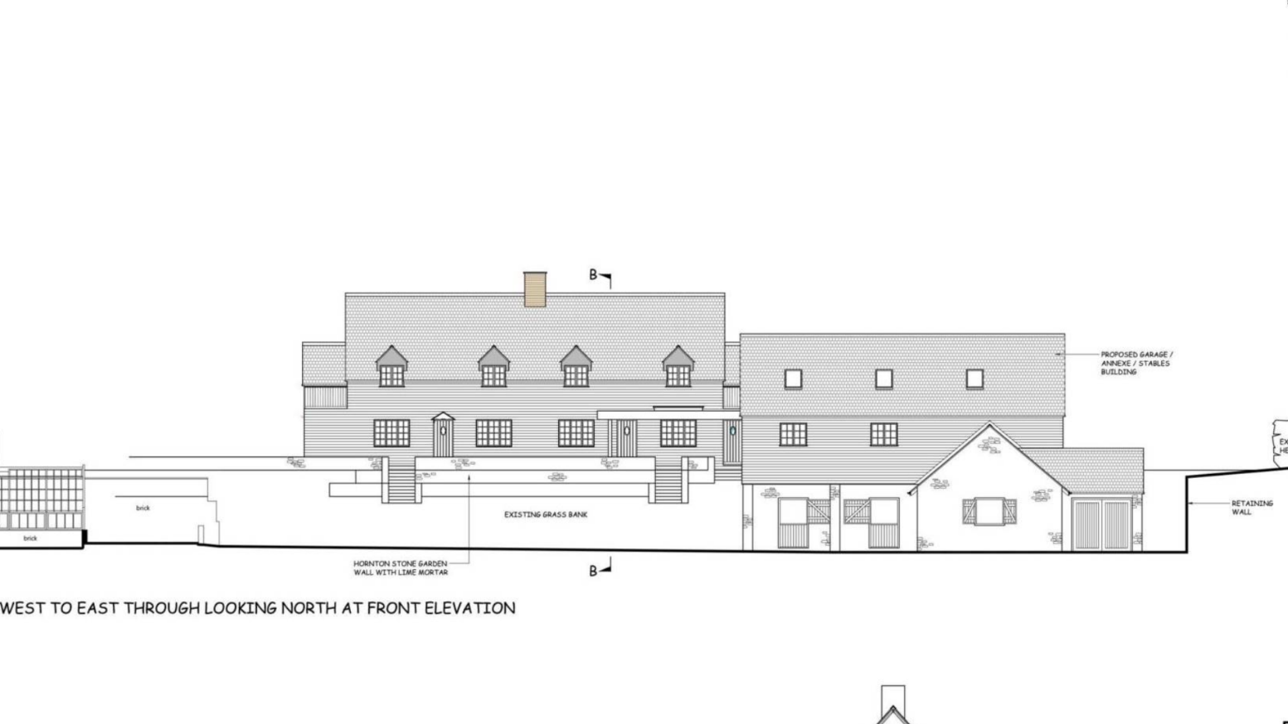

Recommendation – No Objection subject to
- A condition being added that residential use remain ancillary to the dwelling house.
- A condition being added that equestrian use remain private and incidental to the dwelling house.
- Samples of materials being submitted for approval of the LPA.

Make no representation. |  | Object |  | Date Decision made
Support the application. |  | No Objection |  | Who will represent the PC at committee?
Current Tree Consultations – None

Decisions Issued Since Last Tysoe Parish Council Meeting

Application Number | Address | Details | Tysoe Parish Council Comments | Target date for Decision | Decision Date | Decision
23/02010/FUL | Tysoe Vale Farm, Bungalow At Tysoe Road Lower Tysoe Warwickshire CV35 0DY | Proposed demolition of stable block and erection of replacement building containing three garages and stores for domestic use in association with 3 existing dwellings Tysoe Vale Farmhouse, Barn, and Bungalow at Tysoe Vale Farm | Permission with conditions | 13/12/2023 | 29/11/2023 | Permission with conditions

Previous Consultations, still Pending Consideration

Application Number | Address | Details | Target date for decision
23/03019/FUL | 13 Avon Avenue Tysoe Warwickshire CV35 0SP | Construction of new garage, home office and home gym | 04/01/2024
23/02934/FUL | Byeways Main Street Middle Tysoe Tysoe Warwickshire  CV35 0SW | Erection of summer house | 25/12/2023
23/01881/FUL | Willow House Lower Tysoe Road Lower Tysoe Warwickshire CV35 0BN | Rebuild and refurbishment of existing outbuildings relocating existing uses within refurbished structure with covered link to main dwelling. | 21/12/2023
23/02679/FUL | Dinsdale Cottage Baldwins Lane Upper Tysoe Warwick CV35 0TX | Construction of a new vehicular entrance to dwelling house | 29/11/2023
23/02177/COUNTY/  SDC/23CM011 | Sewage Works, Back Lane, Tysoe | Installation of one kiosk (motor control centre) at Sewage Treatment Works, West of Lower Tysoe, Warwickshire | Not published
23/01010/FUL | Land North of Somerton House Lower Tysoe Warwick CV35 0BZ | Construction of single, detached, self-build dwelling | 04/08/2023
22/02935/FUL | Land Adjacent to Hardwick Gorse Tysoe Road Kineton Warwick | Construction of anaerobic digestion facility, comprising silage clamps, digestor tanks, lagoons, administrative buildings, landscaping and access. | 03/01/2023
22/01806/FUL  22/01807/LBC | Home Farm Lower Tysoe Warwick  CV35 0BZ | Residential development of redundant farm buildings, including listed stable, to 3 residential dwellings | 11/08/2022

