Planning Committee Report – February 2024
Current Consultations

Application Number |  | Address |  |  | Details | Consultation Expiry
24/00219/FUL |  | Byeways Main Street Middle Tysoe Tysoe Warwickshire CV35 0SW |  |  | Garage conversion into a garden office with new skylight window and replacement of existing door | 23/02/2024
Description Refurbishment of existing garage by replacement of the roof with like-for-like materials, replacement door and window and the addition a a new window, skylight and internal insulation. The planning committee considers that the proposal use, limited external alterations, with no extension of floor area, suggest that the propsal is ancillary to the enjoyment of the existing dwelling (Byeways) and therefore does not fall within the definition of ‘development’ requiring planning permission.
The plans submitted with the application are poor and inaccurate in content. However, working on the fact that the existing floor plan and the proposed floor plan both show the existing garage doors are being retained, then the building could be re-used as a garage in the future if needed.

Recommendation – No Objection, subject to matching materials.
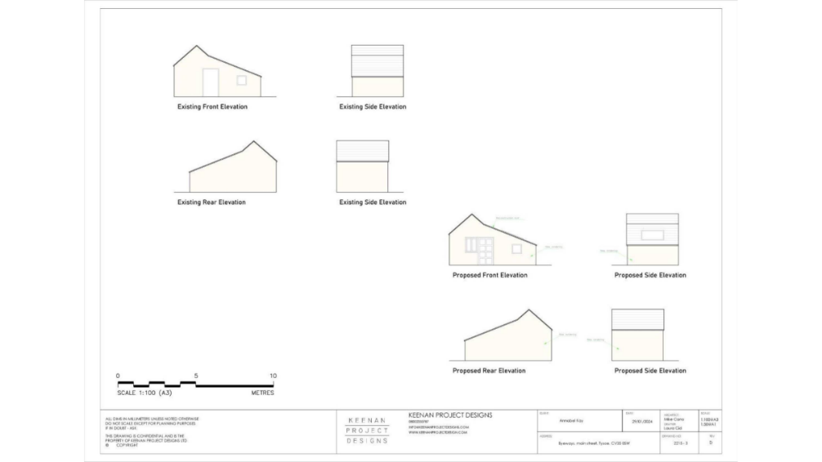

Make no representation. |  |  | Object |  | Date Decision made
Support the application. |  |  | No Objection |  | Who will represent the PC at committee?
Application Number | Address |  |  | Details |  |  | Consultation Expiry
23/03179/FUL | Winchcombe Farm Shenington Road Upper Tysoe Warwickshire  CV35 0TH |  |  | Change of use of two buildings from residential holiday let usage to residential usage ancillary to the main building. No changes to internal or external layout or appearance |  |  | 29/01/2024
Description
This application is very similar to a previous application (23/01946/FUL) which TPC objected to last October and which SDC subsequently refused because changing the use of the two lets, by virtue of their size, range of facilities and severability from Winchcombe Farm, would be tantamount to the creation of new dwellings and so would conflict with CS.20.
This new application is accompanied by documents which aim to show that the holiday let business is no longer viable unless these two lets are changed to residential use. Whilst the additional financial information shows the holiday let business is losing money, we do not believe this provides enough evidence that the business could not be made viable, for example by cutting expenditure or pricing the lets more affordably. Therefore, we see no reason to change our previous objection.

Recommendation – Objection for the same planning reasons as for Application 23/01946/FUL

Make no representation. |  | Object |  | Date Decision made
Support the application. |  | No Objection |  | Who will represent the PC at committee?

Current Tree Consultations – None

Decisions Issued Since Last Tysoe Parish Council Meeting

Application Number | Address | Details | Tysoe Parish Council Comments | Target date for Decision | Decision Date | Decision
23/01881/FUL | Willow House Lower Tysoe Road Lower Tysoe Warwickshire CV35 0BN | Rebuild and refurbishment of existing outbuildings relocating existing uses within refurbished structure with covered link to main dwelling. | No objection | 21/12/2023 | 19/01/2024 | Permission with Conditions
Previous Consultations, still Pending Consideration

Application Number | Address | Details | Target date for decision
23/03194/FUL | Woodside House  Banbury Road  Sunrising Hill  Tysoe Warwickshire OX15 6HR | Alterations and extensions to dwelling, engineering works for creation of swimming pool, link to and erection of outbuilding providing garaging, ancillary accommodation including annex and stables (comprising 3 x stables, tack room, wash down area and feed/hay store), change of use of land to equestrian (private use), access track, and all associated works | 27/02/2024
23/03019/FUL | 13 Avon Avenue Tysoe Warwickshire CV35 0SP | Construction of new garage, home office and home gym | 04/01/2024
23/02934/FUL | Byeways Main Street Middle Tysoe Tysoe Warwickshire  CV35 0SW | Erection of summer house | 25/12/2023
23/02679/FUL | Dinsdale Cottage Baldwins Lane Upper Tysoe Warwick CV35 0TX | Construction of a new vehicular entrance to dwelling house | 29/11/2023
23/02177/COUNTY/  SDC/23CM011 | Sewage Works, Back Lane, Tysoe | Installation of one kiosk (motor control centre) at Sewage Treatment Works, West of Lower Tysoe, Warwickshire | Not published
23/01010/FUL | Land North of Somerton House Lower Tysoe Warwick CV35 0BZ | Construction of single, detached, self-build dwelling | 04/08/2023
22/02935/FUL | Land Adjacent to Hardwick Gorse Tysoe Road Kineton Warwick | Construction of anaerobic digestion facility, comprising silage clamps, digestor tanks, lagoons, administrative buildings, landscaping and access. | 03/01/2023
22/01806/FUL  22/01807/LBC | Home Farm Lower Tysoe Warwick  CV35 0BZ | Residential development of redundant farm buildings, including listed stable, to 3 residential dwellings | 11/08/2022

Appeals in progress

Application Number | Address | Details | Tysoe Parish Council Comments | SDC Decision | Appeal Start Date | Appeal Decision Date | Appeal Decision
23/02281/FUL | 1 Templar Close Lower Tysoe Warwick CV35 0GT | Erection of decking and fencing. | Objection | Refusal | 08/01/2024

