Planning Committee Report – December 2023

Current Consultations

Application Number |  | Address |  | Details | Consultation Expiry
23/02934/FUL |  | Byeways Main Street Middle Tysoe Tysoe Warwickshire  CV35 0SW |  | Erection of summer house | 29/11/2023
Description This proposal entails the replacement of an existing slate-roofed garage, which is in need of repair, with a timber-clad garden office with GRP roof.
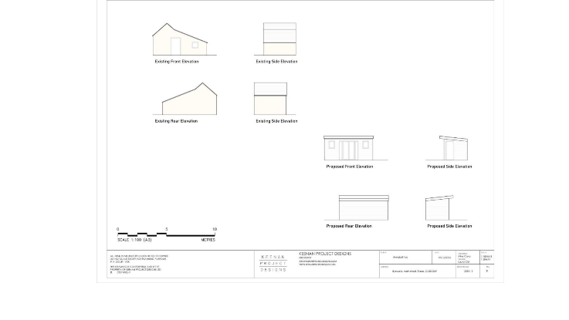
Recommendation – Object for the following planning reasons
- The site lies within the Tysoe Conservation Area surrounded by traditional slate/stone buildings with traditional detailing. The design of the proposed summerhouse is of insufficient standard by nature of its design, materials and siting, and would be detrimental to the amenities of the Conservation Area contrary to Tysoe NDP’s Built Environment Policy 1 and CS.8.
- The proposed demolition of the existing garage and the erection of the summerhouse in its place will remove the only (onsite) parking to the detriment of highways safety.
The site boundaries should also be checked as it would appear that part of the neighbouring property is included.
Make no representation. |  | Object |  | Date Decision made
Support the application. |  | No Objection |  | Who will represent the PC at committee?

Application Number | Address |  |  | Details | Consultation Expiry
23/01881/FUL | Willow House Lower Tysoe Road Lower Tysoe Warwickshire CV35 0BN |  |  | Rebuild and refurbishment of existing outbuildings relocating existing uses within refurbished structure with covered link to main dwelling. | 04/12/2023
Description The proposal entails the conversion (by mainly minor alterations) of an existing outbuilding to the rear of the existing dwelling. It is presently used as stables, store, home office, treatment room and lean-to and would be converted into a building of similar use, namely home office, treatment room containing additional meeting area, stores, WC, tea/coffee point with a garage/trailer store. The external brick walls of the building will remain the same. Although the existing corrugated roof will be replaced with a slate roof.
There will be a new flat-roofed (with lantern light) covered terrace between the existing house and the revamped treatment area.
In addition, the existing barn at the rear will be replaced with a stable block providing two stables and equipment/hay store. The proposal shows the building to be slightly wider to match the adjoined treatment building. The building will be similar in height to the existing barn, constructed in timber-clad boarding on a block/brick wall with a profiled sheet roof cladding.

Recommendation – No objection
The applicants do not wish to apply for a change of use, stating that one partner has worked from a home office, on an ad-hoc basis, for over 10 years and that the other has had a treatment room for soft-tissue physiotherapy, with no more than 10 appointments per week. It would appear that the 10-year rule is irrelevant in the circumstances; the existing and proposed use as described in the application, because of their minor nature, would seem to fall within the definition of a use that is incidental to the enjoyment of the dwelling house. There seems to be adequate parking for the present activities and so we raise no objection subject to:
- A condition being added that use remain ancillary and incidental to the dwelling house.
- Samples of materials being submitted for approval of the LPA.

Make no representation. |  | Object |  | Date Decision made
Support the application. |  | No Objection |  | Who will represent the PC at committee?

Application Number | Address |  |  | Details | Consultation Expiry
23/03019/FUL | 13 Avon Avenue Tysoe Warwickshire CV35 0SP |  |  | Construction of new garage, home office and home gym | 06/12/2023
Description This proposal is for an outbuilding containing a garage, home office, WC and gym, with rendered walls and stone quoins, a natural slate roof, and grey u-pvc windows - all to match the main house. There is existing planning permission for a garage with the same materials. The development would be at the back of the garden.

Recommendation – Object for the following planning reasons
- The proposed building by reason of its size, mass and siting in relationship to adjoining boundaries would be detrimental to the amenities of the neighbouring residential properties and would be contrary to Tysoe NDP’s Built Environment Policy 2 and CS 9-2.
- The proposal will set an undesirable precedent for future out-of-scale back-land development in adjoining gardens, to the detriment of the environment of the area as a whole.

Make no representation. |  | Object |  | Date Decision made
Support the application. |  | No Objection |  | Who will represent the PC at committee?

Current Tree Consultations - None

Application Number | Address | Details | Consultation Expiry | Planning Committee Recommendation

Decisions Issued Since Last Tysoe Parish Council Meeting

Application Number | Address | Details | Tysoe Parish Council Comments | Target date for Decision | Decision Date | Decision
23/02800/TREE | The Cottage Peacock Lane Tysoe Warwickshire CV35 0SG | -T1 yew - Crown lift up to 3.5metres removing lower epicormic growth. -T2 apple - Crown reduction by 3metres to bring it back to it's previous size and in scale. -T3 and T4 apple - Crown reduction by 2metres to bring scale back to previous size. -T5 and T6 pear - Reduction in height by 4metres, scale to be re-aligned with the rest of the garden. -T7 alder - Fell. -T8 hazel - Coppice to manage re-growth and keep away from highway. -T9 plum - 2metres off the top, in line with the rest of the orchard. | No Objection | 28/11/2023 | 24/11/2023 | Tree Consent with Conditions
23/02823/FUL | 13 Poolgate Upper Tysoe Tysoe Warwickshire CV35 0TS | Erection of single storey side extension following demolition of garage. | No Objection, subject to conditions | 13/12/2023 | 29/11/2023 | Permission with conditions
20/03658/FUL | Land Off Sandpits Road Tysoe | Full Planning application for proposed removal of existing building and proposed development of 31 new residential dwellings, new vehicular and pedestrian access, public open space, landscaping and other associated works. | Support | 03/03/2022  (Revised) | 30/11/2023 | Finally Disposed Of
23/02968/TREE | Holly House 11 Smarts Lane Upper Tysoe Warwick CV35 0TT | T1, T2 and T3 - hornbeam - Crown reduce to similar size and shape to approx 1.2metres to a conical form | No Objection | 15/12/2023 | 05/12/2023 | Tree Consent with Conditions
23/01946/FUL | Winchcombe Farm Shenington Road Upper Tysoe Warwickshire  CV35 0TH | Change of use of two buildings from residential Holiday Let usage to residential usage ancillary to the main building. No changes to internal or external layout or appearance | Objection | 15/09/2023 | 05/12/2023 | Refusal of Planning Permission

Previous Consultations, still Pending Consideration

Application Number | Address | Details | Target date for decision
23/02010/FUL | Tysoe Vale Farm, Bungalow At Tysoe Road Lower Tysoe Warwickshire CV35 0DY | Proposed demolition of stable block and erection of replacement building containing three garages and stores for domestic use in association with 3 existing dwellings Tysoe Vale Farmhouse, Barn, and Bungalow at Tysoe Vale Farm | 13/12/2023
23/02679/FUL | Dinsdale Cottage Baldwins Lane Upper Tysoe Warwick CV35 0TX | Construction of a new vehicular entrance to dwelling house | 29/11/2023
23/02177/COUNTY/  SDC/23CM011 | Sewage Works, Back Lane, Tysoe | Installation of one kiosk (motor control centre) at Sewage Treatment Works, West of Lower Tysoe, Warwickshire
23/01010/FUL | Land North of Somerton House Lower Tysoe Warwick CV35 0BZ | Construction of single, detached, self-build dwelling | 04/08/2023
22/02935/FUL | Land Adjacent to Hardwick Gorse Tysoe Road Kineton Warwick | Construction of anaerobic digestion facility, comprising silage clamps, digestor tanks, lagoons, administrative buildings, landscaping and access. | 03/01/2023
22/01806/FUL  22/01807/LBC | Home Farm Lower Tysoe Warwick  CV35 0BZ | Residential development of redundant farm buildings, including listed stable, to 3 residential dwellings | 11/08/2022

