County Councillor report Tysoe Parish Council Meeting 13th May 2024
Warwickshire Strategic Economic Plan
This is an exciting time for Warwickshire, as members of Warwickshire County Council have given their approval for the new Warwickshire’s Strategic Economic Plan at Cabinet. This is a Warwickshire wide strategy that sets out the purpose for Warwickshire to have an economy this is ambitious, inclusive and sustainable.
Ambitious Growth: Warwickshire aims to position itself as a dynamic and resilient economy.
Inclusive Growth: Warwickshire will focus on nurturing a skilled workforce.
Sustainable Growth. Warwickshire aims to embrace green technologies and reduce carbon emissions. Read more: https://www.warwickshire.gov.uk/news/article/5136/sthnologies and reduce carbon emmissionsrategic-economic-plan-approved-at-cabinet

LCE Fund pumps £2.5million into businesses in two years
A scheme launched by Warwickshire County Council to give a helping hand to start-up, micro, small and medium businesses has distributed nearly £2.5 million of funding in less than two years. The Local Communities & Enterprise Fund (LCE) was started in June 2022 to provide loans to businesses who were struggling to access lending by the usual High Street banking routes. It has now distributed over £2,484,368 in loans between 44 businesses as well as social enterprises. The LCE Fund, which is delivered by Coventry and Warwickshire Reinvestment Trust (CWRT), is part of the County Council's £64 million Warwickshire Investment Fund (WIF), to boost the county’s post-pandemic economic recovery.
Warwickshire chosen as pathfinder for national reform of children’s social care services
Warwickshire County Council has been successful in its application to the Department for Education for Wave 2 of the Families First for Children Pathfinder Programme. Warwickshire is one of the seven new areas to deliver the programme which aims to improve services to help more children stay with their families in safe and loving homes. The programme will make sure targeted early help is available for families suffering domestic abuse, addiction, or poor mental health. Where child protection is necessary, it will be carried out by social workers with greater expertise and experience, and the wider family will stay involved in decision-making. For more information, visit Families first for children (FFC) pathfinder programme and family networks pilot (FNP) - GOV.UK (www.gov.uk)
New strategy launched to prevent serious violence in Warwickshire
Warwickshire communities at risk from serious violence will benefit from the launch of a new strategy to tackle both the occurrences and underlying causes of violence.
The Serious Violence Prevention Strategy 2024-30 sets out how members of the Safer Warwickshire Partnership will deliver on a shared long-term commitment to prevent violence before it happens and keep communities safe.
Whilst Warwickshire is a safe place to live, it is not immune to serious violence and the strategy acknowledges the devastating impact that violence can have, tearing families apart, dividing friends, and creating fear in our schools and our communities. Find out more: www.warwickshire.gov.uk/news/article/5115/new-strategy-launched-to-prevent-serious-violence-in-warwickshire

Measles
Two doses of the MMR vaccine offer protection for life against measles, mumps and rubella. For people who do not touch any pork products, there is a version of the MMR vaccine which does not use porcine gelatin in its production. This vaccine is safe and effective.
If you’re not sure, contact your GP about getting catch up jabs. One infected measles case can infect 9 out of 10 unvaccinated people if they spend 15 minutes or more with them. More info: https://www.nhs.uk/MMR
Whooping Cough
Whooping cough affects all ages, but for unvaccinated babies and very young children it can cause serious complications.
It’s vital that pregnant women get vaccinated to protect their babies from birth and parents ensure infants receive their vaccines at 8, 12 and 16 weeks of age or as soon as possible after that.
We're encouraging all pregnant women in #Warwickshire to contact their GP surgery or antenatal clinic to get vaccinated.
Council highlighting mental health and wellbeing support available to residents throughout May
There are a range of mental health and wellbeing services and support available across Warwickshire that can help residents to improve their wellbeing and support them during difficult times. Throughout May, Warwickshire County Council (WCC) will be signposting to the variety of mental health services available across the county and highlighting the importance of looking after your mental health and wellbeing, whatever your situation.
WCC will also be supporting Dementia Action Week which takes place from 13 to 19 May. There are over 8,500 people living with dementia in Warwickshire and one in three people born in the UK today will be diagnosed with dementia in their lifetime. The confirmation of a diagnosis may trigger depression and anxiety in some people and those around the person will also have their own emotional reactions to cope with. It is important that both the person with dementia and those around them feel able to express their feelings and seek supportFor support with mental health, visit warwickshire.gov.uk/mentalhealth.
Financial stress
Are you struggling to balance household budgets? There is financial support available in Warwickshire when you need it. If money worries are making you feel stressed, take steps to look after your health. Find out more: https://www.warwickshire.gov.uk/news/article/5170/find-financial-support-and-reduce-stress
Warwickshire Resilience Forum
Warwickshire Resilience Forum launches new website to boost emergency preparedness News Release Warwickshire Resilience Forum’s new website aims to help you prepare for emergencies across the county. Warwickshire Resilience Forum (WRF) is a partnership of public, private, and voluntary sector organisations. The website identifies who you should contact if one of the key risks occurs in your area, or if you are particularly likely to be affected. You can enter your postcode, and the site will direct you to your key local contacts for the selected risk. For more information go to www.warwickshireresilienceforum.org.
Delivering Better Value Programme for SEND
Warwickshire County Council’s Cabinet has officially endorsed four pivotal projects proposed as part of the Special Educational Needs and Disabilities (SEND) Delivering Better Value Programme.
Read more: https://www.warwickshire.gov.uk/news/article/5214/cabinet-endorses-delivering-better-value-programme-for-send
Upper Lighthorne Primary Heath Care Facility
The new GP Practice on the new development at Upper Lighthorne has been awarded to St. Wulfstan Surgery who are based in Southam.
Social Care and Support recruitment event
People will be encouraged to choose a career with Warwickshire County Council at an Adult Social Care and Support recruitment fair and showcase event later this month. Read more: https://www.warwickshire.gov.uk/news/article/5210/warwickshire-recruitment-event-for-people-looking-to-advance-their-career-in-social-care-and-support
The King's Awards for Enterprise 2024
The King's Awards for Enterprise have been awarded to Warwickshire businesses this year. Aston Martin Lagonda, Gaydon, Innovation Centre, Warwick, runyourfleet, Henley in Arden and RYSE Shipston on Stour https://www.warwickshire.gov.uk/news/article/5198/record-number-of-warwickshire-winners-of-the-king-s-awards-for-enterprise-2024
Queensway and Ford Foundry Roundabouts works
Work on the improvements to Queensway and Ford Foundry roundabouts will start on Monday May 13th and due for completion in summer 2025. Find out more: https://www.warwickshire.gov.uk/news/article/5174/work-to-improve-queensway-and-ford-foundry-roundabouts-start-date-announced-
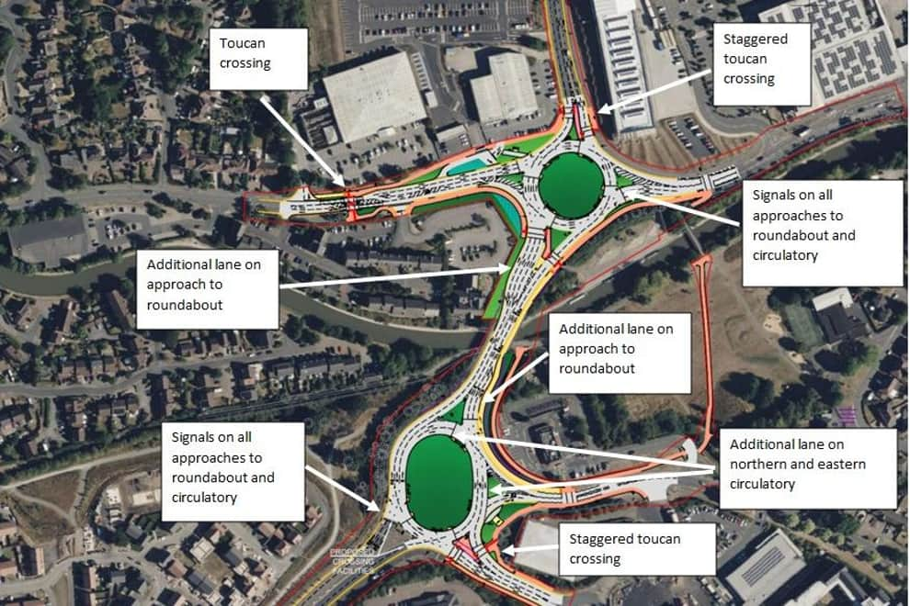
Chris Mills
County Councillor

