County Councillor report Tysoe Parish Council Meeting 10th July 2023
Warwickshire County Council launches a Social Fabric Fund
An innovative new fund that will invest in the power of communities has been given the green light by Warwickshire County Council.
The £2.5m Warwickshire Social Fabric Fund will provide a route to explore the development of local projects and initiatives that will have a positive impact on communities. The fund will look to allocate resources across the county to areas where they can have the most impact. This new fund will help tackle inequalities across the county.
More information about the Social Fabric Fund is available on the Heart of England Community Foundation website: www.heartofenglandcf.co.uk/warwickshire-county-council-social-fabric-fund/
Mental Health Wellbeing Counselling and Support
If you are struggling with your mental health, there is support available for you. Visit www.wellbeingforwarwickshire.org.uk or call 0800 616171 for free, safe and anonymous mental wellbeing counselling and support.
New Community Autism Support Service
Autistic people in Coventry and Warwickshire, or those awaiting a diagnosis, are now able to access improved support through the all-age autism support service. Read more: https://www.warwickshire.gov.uk/news/article/4231/new-community-autism-support-service-launches-to-support-people-across-coventry-and-warwickshire
Utility bill support
Warwickshire residents struggling to pay their utility bills can look to the county council for support.
Find out more: https://www.warwickshire.gov.uk/news/article/4248/utility-bill-support-from-warwickshire-county-council
Free School Meals
Children aged 4-7 automatically get a free lunch, but applying for free school meals will unlock extra support, such as free activities and food during the school holidays. Find out more: www.warwickshire.gov.uk/education-learning/apply-free-school-meals
This July, embrace sustainability and be a part of the movement to reduce single use plastics
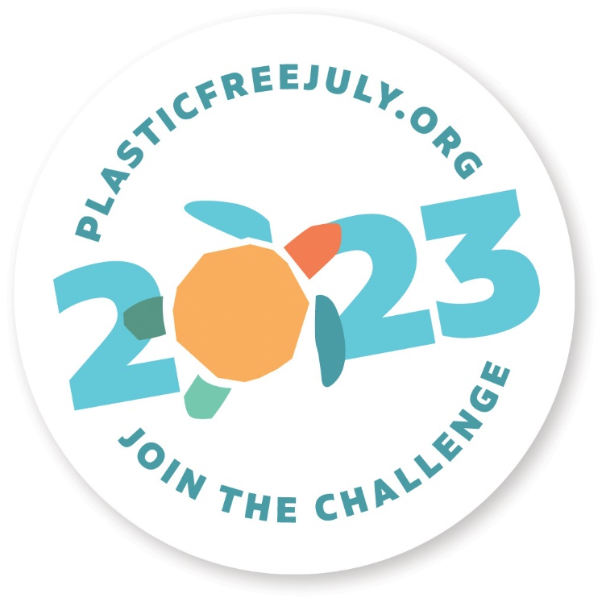
Residents are urged to ditch the single-use plastic with a series of helpful tips as part of Warwickshire County Council’s support for the Plastic Free July campaign.
Plastic pollution is a real problem that affects our environment, our health and wellbeing and contributes to carbon emissions:
Over 2 million plastic bags are used every minute worldwide and the average time that a plastic bag is used in its lifetime before being discarded is 12 minutes; One million plastic bottles are bought every minute worldwide; 32% of all plastic packaging produced finds its way to our oceans every year; You will ingest an average of 70,000 microplastics each year!
Given the scale of the problem, Warwickshire County Council is asking residents to consider how they might reduce the amount of single use plastics. To help, the Council will share a daily tip for each of the 31 days of the month across its social media channels and website.
Find out more about plastic-free July 2023 on the Plastic Free Foundation website: https://www.plasticfreejuly.org/
For more information about how Warwickshire County Council is facing the challenges of the climate change emergency, visit: https://www.warwickshireclimateemergency.org.uk/
Warwickshire's Strategic Economic Plan
WCC’s strategic economic plan for Warwickshire will focus on three key areas: Ambitious Growth, Inclusive Growth and Sustainable Growth.
You can read more about the plan here: https://business.warwickshire.gov.uk/june-2023/news-in-brief/warwickshires-strategic-economic-plan-opens-for-public-views
Applying to change schools in September
Warwickshire families who want their child to start a new school this September are being encouraged to apply now.
Find out how to apply: https://www.warwickshire.gov.uk/news/article/4237/now-is-the-time-to-apply-to-change-schools-in-september
Leamington Farmer
A Leamington Spa farmer who committed a number of animal health offences including causing unnecessary suffering to a ewe that had to be euthanised has been handed a 16 week prison sentence, suspended for 12 months and banned from keeping animals. The prosecution was brought by Warwickshire County Council Trading Standards.
Mr Ewan David Wells (age 64) of Main St. Hunningham, Leamington Spa had already pleaded guilty to three Animal Health offences in December 2022 and appeared at Coventry Magistrates Court on 29th June 2023 for sentencing.

Chris Mills
Kineton and Red Horse

