County Councilor report Tysoe Parish Council 10th June 2024
Warwickshire County Council’s Councillor Grant
Round one of the Councillors’ Grant Fund 2024/25 was launched on 20th May with a deadline of 30th June at 5pm. Applications can be submitted on the Council’s website. There are two different forms depending on whether the grant needed is over or under £350.00. The full category list can be seen on the website: https://www.warwickshire.gov.uk/cllrgrants
Improved economic outlook for Coventry and Warwickshire
The economic outlook for Coventry and Warwickshire has improved, as the Coventry and Warwickshire Chamber of Commerce’s latest Quarterly Economic Survey says the region is in better shape than it was at the turn of the year.
Find out more: www.warwickshire.gov.uk/news/article/5260/improved-economic-outlook-for-coventry-and-warwickshire
Mental health support services
Suicide is preventable through education and intervention, which is why Warwickshire County Council is highlighting the support available for those struggling with their mental health and wellbeing. Find out more: www.warwickshire.gov.uk/news/article/5264/council-promotes-support-services-available-to-residents-struggling-with-their-mental-health
Refugee week
Warwickshire County Council are supporting Refugee Week, which is taking place 17 – 23 June. The theme for this year is ‘Our Home’. To celebrate Refugee Week, why not show simple acts of kindness like having a chat, walking together, or sending a message of welcome to help everyone feel at home and like they belong. Learn more: https://refugeeweek.org.uk/
World No Tobacco Day
As part of World No Tobacco Day on Friday 31 May, Warwickshire County Council were encouraging more smokers in Warwickshire to quit and make use of the free stop smoking services available to residents. Recently, WCC received £786,180 in funding from the government to increase stop smoking services and reduce smoking rates across the County. There are over 66,000 people in Warwickshire who smoke which is 13.9% of adults aged 18 plus in the County. Over the next 12 months the Council will be raising the awareness around the dangers of smoking as well as vaping, with the clear message: “if you don’t smoke don’t vape”. Find out more: www.warwickshire.gov.uk/news/article/5270/smokers-encouraged-to-make-use-of-stop-smoking-services-in-warwickshire-for-world-no-tobacco-day-
I need support now
If you are struggling with money and need help now, we can help with:
Food, energy and water bills, money advice, aspects of family life, accessing emergency food and mental health support. Find help here: https://www.costoflivingwarwickshire.co.uk/home/i-need-urgent-help
Family Information Service
Warwickshire’s Family Information Service (FIS) provides information, advice and one-to-one support on issues including family relationships, finance, housing, parenting support and more. Learn more at https://www.warwickshire.gov.uk/directory-record/40/family-information-service
SEND change in Warwickshire
Over the last six months, Warwickshire County Council has made significant strides in developing services and support for children and young people with SEND.
Read more: https://www.warwickshire.gov.uk/news/article/5278/send-change-remains-a-focus-in-warwickshire
Nuisance bikes
If bikes are being used in a manner which causes alarm, distress or annoyance, Warwickshire Police can issue notices or seize the bike. Report them now at http://warwickshire.gov.uk/dobemin or call 101 (non-emergency)
80th anniversary of the Normandy Landings
Warwickshire’s Lord Lieutenant, Tim Cox, has participated in two significant events to mark the 80th anniversary of the Normandy Landings.
Find out more: https://www.warwickshire.gov.uk/news/article/5288/warwickshire-lord-lieutenant-attends-events-to-commemorate-d-day-landings
New Statue of ‘Bobby’ The Antelope unveiled
A bronze statue of Bobby the Blackbuck Antelope, the official mascot for the Royal Warwickshire Regiment and most recently The Royal Regiment of Fusiliers has been unveiled.
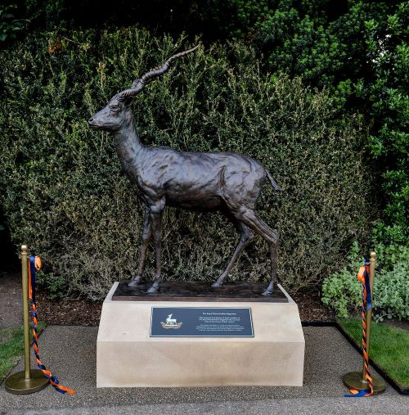

Read more: https://www.warwickshire.gov.uk/news/article/5289/new-statue-of-bobby-the-antelope-unveiled-by-hrh-the-duke-of-kent-at-warwick-castle
Ticket Fraud
Summer is here, and with some of the biggest names in music hitting the road, Warwickshire Police and Safer Warwickshire partners are urging you to be careful to avoid falling victim to #TicketFraud. For more information, see http://star.org.uk/buy_safe

Chris Mills
County Councillor

