County Councillor report Tysoe Parish Council Meeting 9th December 2024
Support managing winter challenges
Support is available in Warwickshire to help people who might be feeling lonely, stressed or unwell due to social and financial pressures this winter. Find out more here: https://www.warwickshire.gov.uk/news/article/5776/help-for-warwickshire-residents-to-manage-winter-challenges
Domestic abuse and family relationships
The festive season isn’t always the most wonderful time of the year. For victim/survivors of domestic abuse it can mean physical harm to them and any dependents. Domestic Abuse is a crime. Warwickshire is here to help you. For advice, please go to www.talk2someone.org.uk. In an emergency, call 999. #YouAreNotAlone 0800 408 1552
Suicide prevention
If you, or someone you know, is having thoughts of suicide or significant self-harm, help and support is available now. Visit dearlife.org.uk where you will find mental health and suicide prevention information and advice. For urgent support, please call 111 (or visit 111.nhs.uk) and choose the mental health option. Calls will be answered by a trained mental health professional who will be able to quickly assess the situation and determine whether an urgent referral is required. If there is immediate risk to life, call 999.
Log burners
Do you have a log burner in your home?
Using wet wood, treated waste wood, such as old furniture, or household waste can be dangerous for your health as it can emit harmful fumes and toxic pollutants into your home when burnt. Switch to Ready to Burn wood for a safer alternative and make sure to have a carbon monoxide alarm fitted for your safety.
I need support now
Paying for my food, energy and water. If you are a Warwickshire resident with no other access to funds to pay for food or energy bills, you may be eligible for support through the Local Welfare Scheme. For more information, visit the Local Welfare Scheme pages or call 0800 4081448 or 01926 359182. Phone lines are open Monday to Thursday from 9am to 5pm and Friday from 9am to 4.30pm.
Warwickshire Holiday Activities & Food Programme
Warwickshire County Council is thrilled to announce that a wide range of fun and free activities to children and young people eligible for benefits-related free school meals during the winter break from school. Read more: https://www.warwickshire.gov.uk/news/article/5793/warwickshire-holiday-activities-food-programme-offers-winter-fun-for-children-and-young-people
Homes for Ukraine scheme – Yuliia’s Story
Over 850 residents in Warwickshire have opened their doors to people in need through the Homes for Ukraine scheme since its introduction in March 2022.
Among these is Yuliia, an aspiring Ukrainian fashion illustrator. This is her story: https://www.warwickshire.gov.uk/news/article/5777/as-the-war-in-ukraine-goes-on-the-support-in-warwickshire-continues-yuliia-s-story
If you have arrived in Warwickshire under Homes for Ukraine and need information in Ukrainian, please call us on 0800 408 1447.
Якщо Ви прибули до Уорвікширу за програмою Homes for Ukraine і Вам потрібна інформація на українській мові, будь ласка, зателефонуйте нам за номером 0800 408 1447
Warwickshire County Council’s guide to managing potholes: how you can help keep roads safe
As we enter the colder months, Warwickshire County Council invites residents to join in the fight against potholes. Potholes form as a natural result of traffic, water, and surface wear. When rainwater seeps into cracks in the road, it freezes and expands, breaking the road surface under the pressure of passing vehicles.
Warwickshire County Council has created an efficient reporting system for residents to quickly notify the Council of potholes, track repair progress, and stay informed on ongoing maintenance. How to Report a Pothole
Residents can help keep roads safe by reporting potholes through the Council’s user-friendly online platform: warwickshire.gov.uk/potholes.
Lithium-Ion battery dangers
Warwickshire Fire and Rescue service is urging residents to take precautions when using and disposing of lithium-ion batteries following a recent rise in fires caused by these common energy sources. While lithium-ion batteries power many of our everyday devices, from smartphones and laptops to e-scooters and electric vehicles, they can pose serious fire hazards if not handled properly. It is an especially important message at a time when people are buying Christmas presents which may contain these types of batteries. Discover more: https://www.warwickshire.gov.uk/news/article/5795/warwickshire-fire-and-rescue-service-warns-of-lithium-ion-battery-dangers
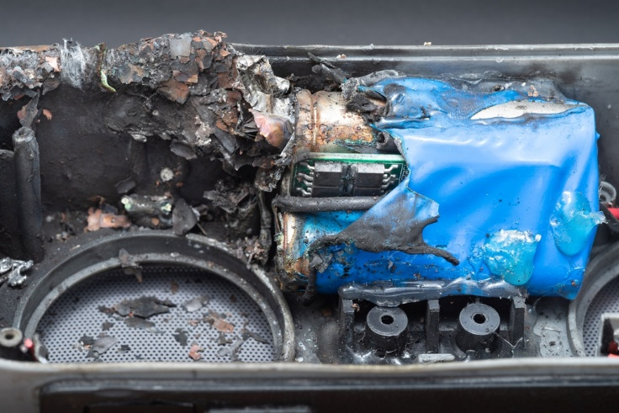
WCC Cabinet – December 2024
Warwickshire County Council’s cabinet meeting will be taking place next Thursday (12 December) and you can watch it live on the website.
Find out what is going to be discussed here: https://democracy.warwickshire.gov.uk/ieListDocuments.aspx?CId=146&MId=3852&Ver=4
Warwickshire’s Lord Lieutenant presents national honours
The extraordinary achievements of several residents in Warwickshire have been recognised in formal presentations and events by the Lord Lieutenant of Warwickshire, Tim Cox. Mrs Janet Nelson of Butlers Marston was presented with the BEM. for services to education.
The King’s Award for Voluntary Service 2024
Two charitable organisations in Warwickshire – Hope 4 Rugby and the Kineton Sports & Social Club – have officially been awarded The King’s Award for Voluntary Service 2024. This is the highest award a local voluntary group can receive in the UK and is equivalent to an MBE.

Child-friendly festive cheer
Warwickshire residents and businesses who want to help children and young people have a happy Christmas are invited to donate presents via a Warwickshire County Council’s gift appeal. Find out more: https://www.warwickshire.gov.uk/news/article/5755/spread-some-child-friendly-christmas-cheer-


Chris Mills
County Councillor
Tysoe

