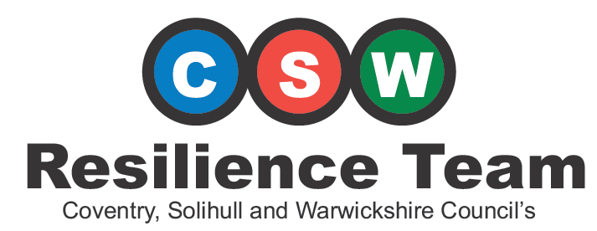

**IN CASE OF EMERGENCY CALL 999**

**HOME EMERGENCY PLAN**

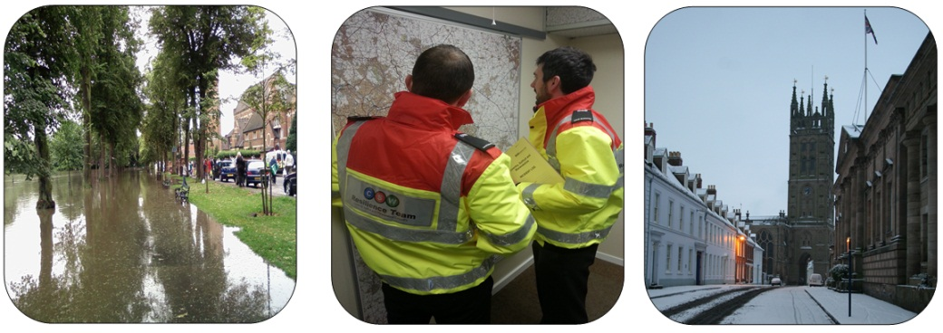A resilience plan to help you and your household be more prepared to deal with emergencies.

|  |  |
| --- | --- |
| Household Name: |  |
| Date: |  |
| Review Date: |  |

**About Us**

The CSW Resilience Team was formed on the 1st of April 2011 and is a combination of Local Authority Emergency Planning Officers from Coventry City Council, Solihull Metropolitan Borough Council and Warwickshire County Council.

This document has been produced to help inform and prepare residents across Coventry, Solihull and Warwickshire for emergency situations.

Emergencies can occur without warning and may cause major disruption. Pre-planning and taking small steps to reduce risks will increase your resilience and help to limit the impacts of incidents. This document can be used to record the important information and the actions that you and your household can take. Be sure to keep it safe and update it regularly.

For more information on emergency planning and resilience visit **CSWprepared.org.uk**

**Contents**

|  |  |
| --- | --- |
| Page | Section |
| 2 | Recognise It – What are the risks? |
| 7 | Discuss It – Talk about what you would do |
| 8 | Document It – Capture important information and actions |
| 12 | Try It – Have a practice |
| 12 | Update It – Revisit your plan regularly |
| 14 | Bag It – Put together an Emergency Grab Bag |

**Recognise It**

The first step of producing any emergency plan is a risk assessment. Simply this involves; recognising the risks that you may be exposed to, understanding what the **chance** is of that risk occurring and what the likely **impacts** would be.

Once the risk has been recognised and assessed you can then work out what actions you can take to either reduce the risk or respond to it.

The following pages list some of the risks that could occur across Coventry, Solihull and Warwickshire. Also think about any other risks that aren’t included here that may affect you and your household.

Prepare for Fires

A fire in your home is one of the biggest risks to you and your property. Detailed information on preparing for fires can be found here:

Warwickshire Residents:[**http://www.warwickshire.gov.uk/fireandrescue**](http://www.warwickshire.gov.uk/fireandrescue)

Coventry & Solihull Residents:[**http://www.wmfs.net**](http://www.wmfs.net)

You may find the following useful in keeping you and your household safe:

* Fire Alarms: Always check the battery regularly and replace it when necessary. Never remove the battery for any other purpose.
* Identify escape routes from each room and keep them clear.
* Ensure everyone knows where keys for doors and windows are kept.
* Take extra care when cooking; avoid cooking when tired or intoxicated.
* Do not smoke in bed.
* Never leave a burning candle unattended.
* Do not overload electrical sockets.
* Close doors at night to slow down the progress of any fire.

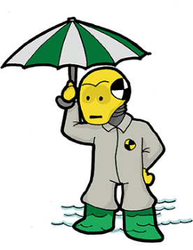You can check your risk of flooding from both surface water and rivers on the Environment Agency website; links to this and other tips and advice on flooding can be found on our website:

Prepare for Flooding

**cswprepared.org.uk/hazard-advice/flooding/**

Please remember that the responsibility to protect property falls on the property owner. Consider exploring flood resilience options. The Blue Pages flood directory ([**https://bluepages.org.uk/**](https://bluepages.org.uk/)) can help with this.

You may find the following useful in keeping you, your household and property safe.

**Before the flood**

* Check you have appropriate insurance for your home and vehicle.
* Move valuable items and documents to higher levels.
* Keep a supply of food and bottled water in the house in case you are unable to get to the shops during a flood.
* If you do not have flood resilience products, consider attempting to improvise methods to block doorways and airbricks (e.g. filling bin liners with soil or other suitable material).

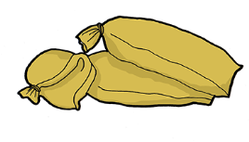

**During the flood**

* Avoid walking or driving through floodwater.
* Turn off utilities at your house.

**After the flood**

* Assume floodwater has been contaminated with sewage.
* Drink bottled water until assured that water supply is free from contamination.

Prepare for Severe Weather

**Heavy Snow or Ice**

* Only drive if absolutely necessary, take extra care and adjust your driving to suit the conditions. Check the RAC or AA website for tips on how to drive in snow/icy conditions.
* Councils have their gritted route maps on their website, use them to plan your journeys.
* ****Check on neighbours and relatives to make sure they are keeping warm and well.
* Consider getting all season / winter tyres or a pair

of vehicle snow socks.

**Storms and Gales**

When storms and gales are forecast:

* Secure loose objects that could cause damage outside.
* Securely fasten doors and windows.
* Park vehicles in a garage if possible, otherwise keep them clear of buildings, walls, fences and trees.

During the storm:

* Stay indoors as much as possible.
* Do not go outside to repair damage until it’s safe to do so.
* Avoid driving, if you must drive take extra care.

After the storm:

* Do not touch any cables that have been blown down.
* Make sure neighbours are safe.
* Ensure any repair work is carried out safely.

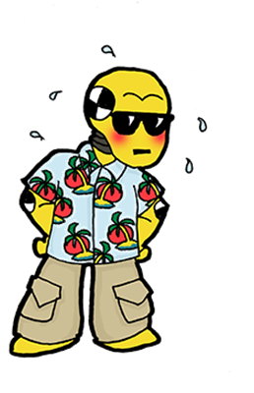**Heatwave**

In periods of high heat you may become dehydrated and your body can overheat, leading to heat exhaustion or heatstroke.

Heatstroke can develop if heat exhaustion is left untreated, but can also occur suddenly and without warning which could result in serious health issues.

Drink cold drinks regularly, avoid going out during the hottest periods of the day and wear loose fitting clothes.

Prepare for Accidents

**Industrial Accident**

There are various industrial sites within Coventry, Solihull and Warwickshire. These sites have robust safety and security measures in place to reduce the risk of a major emergency. In the unlikely event of an emergency the emergency services will issue advice on local media. Residents near the location will either be asked to evacuate or to: **Go In, Stay In & Tune In** **see page 11.**

Prepare for Pandemics

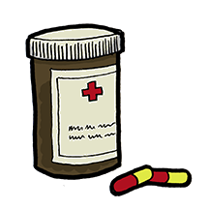**Health**

There are a number of infectious diseases that may lead to localised, national, or even international outbreaks if they are not rapidly controlled. Some of these diseases include Pandemic Influenza, Norovirus (sickness and diarrhoea), Measles and Tuberculosis. Many diseases are not common due to previous vaccination programmes but there is a risk that they may return, or a new virus may develop such as Covid-19.

**You can reduce the risk of catching or spreading any infectious disease by:**

* Covering your nose and mouth when coughing and sneezing – use a tissue.
* Disposing of dirty tissues promptly and carefully – bag and bin them.
* Maintaining good basic hygiene, for example washing your hands frequently to reduce the spread of the virus from your hands to your face or to other people.
* Cleaning hard surfaces (e.g. kitchen worktops, door handles) frequently.

If you are worried about any illness then, unless otherwise directed, you should contact your GP or NHS Services - dial 111 for non-emergency and non-urgent care or go to the NHS Choices website at [**https://www.nhs.uk**](https://www.nhs.uk)

**Discuss It**

Based on the risks that you believe could happen in your area and the likely impacts that they could have on you and your family start to think about what you would do if an emergency occurred.

Discuss your thoughts and proposed actions with friends, family, neighbours or community groups to make them aware of your plans and see if they have any other ideas that you can include in your plan.

Think about where you could go if you had to leave your home in an emergency. Where could you go, who would you need to tell and what routes would you take?

|  |
| --- |
| Notes: |

**Document It**

|  |  |  |
| --- | --- | --- |
| Risk | Methods To Reduce Risks | Action |

After you’ve recognised the risks and talked about what actions you would take, use this section to document information and contact details that may be useful in an emergency.

**Document It:**

|  |  |  |  |  |  |  |
| --- | --- | --- | --- | --- | --- | --- |
| **Emergency Meeting Places** | | | | | | |
| Near-by | |  | | | | |
| Out of Area | |  | | | | |
| **Insurance Details** | | | | | | |
| **Insurance** | **Insurer** | | | **Telephone #** | | **Policy #** |
| Home |  | | |  | |  |
| Contents |  | | |  | |  |
| Vehicle |  | | |  | |  |
| Health |  | | |  | |  |
| Pet |  | | |  | |  |
| **Utility Providers** | | | | | | |
| **Service** | | | **Provider** | | **Telephone #** | **Account #** |
| Electricity | | |  | |  |  |
| Gas | | |  | |  |  |
| Water | | |  | |  |  |
| Telephone | | |  | |  |  |
| Internet | | |  | |  |  |
| Breakdown Cover | | |  | |  |  |

|  |  |  |  |  |
| --- | --- | --- | --- | --- |
| **Emergency Contacts** | | | | |
| **Contact** | | **Name / Location** | | **Telephone #** |
| Doctor / GP | |  | |  |
| Dentist | |  | |  |
| Vet | |  | |  |
| Landlord | |  | |  |
| Local Hospital | |  | |  |
| **Household Members** | | | | |
| **Name** | **Passport #** | | **NHS #** | **Medication** |
|  |  | |  |  |
|  |  | |  |  |
|  |  | |  |  |
|  |  | |  |  |
|  |  | |  |  |
|  |  | |  |  |
| **Vehicle Reg(s)** |  | | | |

**Actions you can take:**

To prepare for an emergency, you should take time to find out:

* Where and how to turn off your water, gas and electricity supplies.
* The emergency procedures for your children at school.
* The emergency procedures at your workplace.
* How your household will stay in contact in the event of an emergency.
* If any elderly or vulnerable neighbours might need your help.
* How to tune in to your local radio station (turn to page 13).

**Go In, Stay In & Tune In**

If you experience an emergency situation it is likely that the emergency services will take one of two approaches. They will either evacuate residents to a place of safety until the situation can be dealt with or they will ask residents to shelter in their homes and listen to local media stations for information and advice about what actions to take.

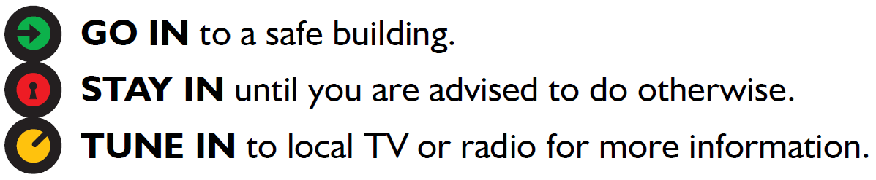The advice is to **‘Go In, Stay In & Tune In’**

Local media stations have agreed that if there is a major emergency they will interrupt programming to give public safety advice and information about the incident, so that when you TUNE IN locally or nationally anywhere in the UK you’ll get the advice you need.

Of course, there are always going to be particular occasions when you should not “go in” to a building, for example if there is a fire. In this case; Get Out, Stay Out and Call the Emergency Services

**Try it & Update It**

Now that you have planned what you would do in an emergency, why not put it to the test? Regularly practice the actions you have written down to see if you encounter any issues that you hadn’t thought about. Ask yourself the questions below and record any problems or issues that you encounter, being sure to amend your plan to avoid repeating them in an emergency.

|  |  |  |
| --- | --- | --- |
| **Questions** | **YES** | **NO** |
| Do you have a household emergency plan? |  |  |
| Have you discussed your plan with family and friends? |  |  |
| Do you know the emergency plan for your place of work? |  |  |
| Are your contact numbers up to date? |  |  |
| Have you checked if your property is in a flood risk area? |  |  |
| Can you turn off the water, gas and electricity in your home? |  |  |
| Do you have alternative, agreed meeting points? |  |  |
| Do you have working smoke alarms in your home? |  |  |
| Do you have adequate contents and buildings insurance? |  |  |
| Have you undertaken a basic first aid course? |  |  |
| Do you have copies of your important documents in a safe place? |  |  |
| Do you have a written list of your valuables, copies of photographs/home videos? |  |  |
| Do you know the emergency plan for your children’s school/nursery/college? |  |  |
| Do you have a wind up or battery-operated portable FM/AM radio |  |  |
| Have you thought about arrangements for pets if you need to leave your home? |  |  |
| Have you identified possible exit routes from every room in your home? |  |  |
| Do you have someone unlikely to be affected by the same emergency – who can keep family and friends informed? |  |  |
| Have you prepared a check list for your “Emergency Grab Bag”, is it packed and ready to go? (See end of booklet) |  |  |

The information below is a list of details and contacts numbers which may be handy. **In the event of an emergency always call 999.**

**Radio Stations:**

BBC West Midlands: 95.6 FM

BBC Coventry and Warwickshire: 94.8 FM 103.7 FM

Heart FM West Midlands: 100.7 FM

Free Radio Coventry and Warwickshire: 97 FM 102.9FM

**Key contacts:**

|  |  |  |
| --- | --- | --- |
| NHS Choices | 111 | [www.nhs.uk](http://www.nhs.uk) |
| Environment Agency Floodline | 0345 988 1188 | [www.gov.uk/government/organisations/environment-agency](http://www.gov.uk/government/organisations/environment-agency) |
| Police Enquiries | 101 | [www.police.uk](http://www.police.uk) |
| Emergency Power Cut Information | 105 | [www.powercut105.com](http://www.powercut105.com) |
| Gas Leaks | 0800 111 999 | [www.nationalgrid.com/uk/gas-transmission/safety-and-emergencies/emergencies-and-safety-advice](http://www.nationalgrid.com/uk/gas-transmission/safety-and-emergencies/emergencies-and-safety-advice) |
| Severn Trent Water | 0800 783 4444 | <https://www.stwater.co.uk/> |
| National  Highways Information Line | 0300 123 5000 | [www.highwaysengland.co.uk](http://www.highwaysengland.co.uk) |
| Crime Stoppers | 0800 555 111 | [www.crimestoppers-uk.org](http://www.crimestoppers-uk.org) |

I

**Bag It**

In certain very unlikely situations, you may be asked to leave your home by the emergency services. If this happens, leave as quickly and as calmly as possible. And, if you have time:

* Turn off electricity, gas and water supplies, unplug appliances and lock all doors and windows.
* If you leave by car, take bottled water and blankets, and tune in to a local radio station for emergency advice and instructions.
* Take your Emergency Grab Bag.

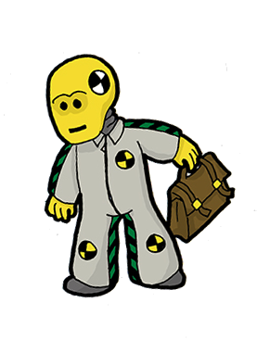Putting together an Emergency Grab Bag is a great way to ensure that you and the members of your household are prepared should you have to leave your home in a hurry. Your Emergency Grab Bag should hold items that would be essential if you had to leave your home quickly. It should contain copies of personal information and items which may help you or provide some comfort in an emergency.

http://www.clipartbest.com/cliparts/dT6/GoR/dT6GoRjT9.png

Your Grab Bag should be small enough for anyone to carry and be kept in a safe place that everyone in your household can easily access.

You could also download additional copies of this booklet to keep in your “Grab Bag” so you have all the information together.

Items you put in the Grab Bag may change seasonally or be dependent on your needs as a household. It should be checked every six months to make sure perishable items are still in date and all information is up to date.

Think about what items your children; particularly babies may need and tailor your Grab Bag around their needs as well as your own. Similarly if you have pets, consider what they would need in an emergency situation and bag these items too.

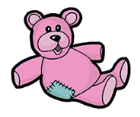Motorists would also benefit from having a grab bag in their vehicles should they get stuck in bad weather conditions or break down. Think about what you would need if you were in this situation.

http://www.clipartbest.com/cliparts/dT6/GoR/dT6GoRjT9.png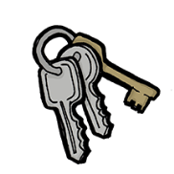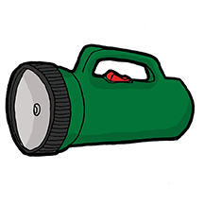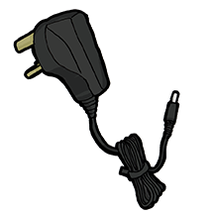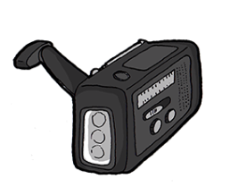

**Emergency Grab Bag Checklist.**

* A small first aid kit and medication
* Copies of important documents in a waterproof bag
* Copies of prescriptions for regular medication
* A battery torch with spare batteries or a wind up torch
* A battery radio with spare batteries or wind up radio
* Bottled water and some non-perishable emergency foods
* Childcare supplies or other special care items
* Notebook with pen and pencil
* Toiletries and sanitary supplies
* Infant supplies
* Spare clothes
* Spare sets of keys
* Mobile phone and charger
* Money
* Spare contact lenses or glasses
* Hi-vis jackets or tabards
* Some warm clothes or blankets
* Any other items that might provide some comfort if you have to leave your home in a hurry.